STREET LIGHT CONTROLLER

USING THERMISTER

# ABSTRACT

Street light is an automated system which automates the street. The street light will glow when the temperature is low and it will turn off, when the temperature is high. Nowadays the street light controller using LDR. But we use the thermistor instead of the LDR which is a temperature sensor. Why the light glow according to the temperature means if the temperature is high the brightness of the surroundings will high and brightness of the environment is low when there is low temperature. Both temperature and brightness of environment depends on the sun rays so we used temperature to glow up the street light. For calculating the temperature thermistor is used. This is the main component. Thermistor is a type of resistor whose resistance is dependent on temperature, more so than in standard resistors. Thermistors are widely used as in rush current limiter, temperature sensors (NTC type typically), self-resetting overcurrent protectors, and self-regulating heating elements. Here we use small computer like device known as microcontroller . Microcontrollers are used in [automatically](https://en.wikipedia.org/wiki/Control_system) [controlled](https://en.wikipedia.org/wiki/Control_system) products and devices, such as automobile engine control systems, implantable medical devices, remote controls, office machines, appliances, power tools, toys and other [embedded systems](https://en.wikipedia.org/wiki/Embedded_system). By reducing the size and cost compared to a design that uses a separate [microprocessor](https://en.wikipedia.org/wiki/Microprocessor), memory, and input/output devices, microcontrollers make it economical to digitally control even more devices and processes. [Mixed](https://en.wikipedia.org/wiki/Mixed-signal_integrated_circuit) [signal](https://en.wikipedia.org/wiki/Mixed-signal_integrated_circuit) microcontrollers are common, integrating analog components needed to control non- digital electronic systems. In the context of the [internet of things](https://en.wikipedia.org/wiki/Internet_of_things), microcontrollers are an economical and popular means of [data collection](https://en.wikipedia.org/wiki/Data_collection), [sensing](https://en.wikipedia.org/wiki/Sensor) and [actuating](https://en.wikipedia.org/wiki/Actuator) the physical world as [edge devices](https://en.wikipedia.org/wiki/Edge_device).

**Keywords :** Thermistor, light, temperature.

|  |  |  |
| --- | --- | --- |
|  | **Table of Contents** |  |
| **Chapter No.** | **Particulars** | **Page No.** |
|  | Vision and Mission of the Institute and Department | 3 |
|  | POs, PSOs of the Department | 4 |
|  | Mapping of project with POs and PSOs | 5 |
|  | Abstract | 6 |
|  | List of Figures | 8 |
| 1 | Introduction | 9 |
|  | 1.1 Background | 9 |
|  | 1.2 Objectives | 10 |
| 2 | Literature Review | 11 |
| 3 | Materials and Methodology | 12 |
|  | 3.1 Block Diagram | 12 |
|  | 3.2 Microcontroller | 13 |
|  | 3.2.1 89c51 Microcontroller Architecture | 14 |
|  | 3.3 Hardware Description | 14 |
|  | 3.3.1 Thermistor | 14 |
|  | 3.3.2 Heat Sensor Circuit | 15 |
|  | 3.3.3 Relay | 15 |
|  | 3.3.4 Power Supply | 16 |
| 4 | Results and Discussions | 17 |
| 5 | Conclusion | 18 |
|  | References | 18 |

# List of Figures

**Figure No.**

**Figure Name**

**Page No.**

* 1. Block diagram for street light controller 12
  2. Pin diagram for microcontroller 13
  3. Thermistor 15
  4. Relay 15
  5. Hardware Configuration 17

# CHAPTER – 1 INTRODUCTION

* 1. **BACKGROUND:**

Our country is suffering from power crisis for a long time. Although some times because of our ignorance, we see street lights are on in the day. The project Automatic Street Light Control System with thermistor and Relay has been successfully designed and tested. Here we are saving lot of power without any wastage, by these advanced technologies we can design many more systems which can be done by solar lights and through these solar lights we have a vast usage at the same time we can do automatic systems instead of doing it manually. The main aim of the project is Automatic Street power saving system with thermistor; this is to save the power. We want to save power automatically instead of doing manual. So, it’s easy to make cost effectiveness. This saved power can be used in some other cases. So, in villages, towns etc we can design intelligent systems for the usage of street lights. The report presents a new and innovative approach to managing street lighting systems. When combining both the sunrise/sunset feature with modern communications intelligent control of the street lighting system will offer significant cost savings because of reduced energy consumption and lower maintenance and operation cost.

The idea of designing a new system for the streetlight that do not consume huge amount of electricity and illuminate large areas with the highest intensity of light is concerning each engineer working in this field. Providing street lighting is one of the most important and expensive responsibilities of a city. Lighting can account for 10-38% of the total energy bill in typical cities worldwide.

Manual control is prone to errors and leads to energy wastages and manually dimming during mid night is impracticable. Also, dynamically tracking the light level is manually impracticable. The current trend is the introduction of automation and remote management solutions to control street lighting. There are various numbers of control strategy and methods in controlling the street light system such as design and implementation of CPLD based solar power saving system for street lights and automatic traffic controller, design and

fabrication of automatic street light control system, automatic street light intensity control and road safety module using embedded system , automatic street light control system , Intelligent Street Lighting System Using GSM , energy consumption saving solutions based on intelligent street lighting control system and A Novel Design of an Automatic Lighting Control System for a Wireless Sensor Network with Increased Sensor Lifetime and Reduced Sensor Numbers. In this paper two kinds of sensors will be used which are light sensor and photoelectric sensor. The light sensor will detect darkness to activate the ON/OFF switch, so the streetlights will be ready to turn on and the photoelectric sensor will detect movement to activate the streetlights. thermistor, which varies according to the amount of light falling on its surface, this gives an induction for whether it is a day-night time, the photoelectric sensors are placed on the side of the road, which can be controlled by microcontroller PIC16f877A. The photoelectric will be activated only on the night time. If any object crosses the photoelectric beam, a particular light will be automatically ON. By using this as a basic principle, the intelligent system can be designed for the perfect usage of streetlights in any place.

# OBJECTIVES:

The main consideration in the present field technologies is Automation, Power consumption and cost effectiveness. Automation is intended to reduce man power with the help of intelligent systems. Power saving is the main consideration forever as the source of the power (Thermal, Hydro etc.,) are getting diminished due to various reasons. The main aim of the project is Automatic Street power saving system with thermistor; this is to save the power. We want to save power automatically instead of doing manual. So, it’s easy to make cost effectiveness. This saved power can be used in some other cases. So, in villages, towns etc we can design intelligent systems for the usage of street lights.

# CHAPTER – 2 LITERATURE REVIEW

In major of the street light controllers the LDRs and solar panels were used. but the major problem is temperature and cost. LDRs are sensitive to temperature when the temperature increases the LDR gives abnormal results. As well as the cost of solar panel also high. So, to solve these problems thermistors were used. Thermistors works depends upon the temperature falls on it. At degree of temperature falls the light glow according to the temperature. The light glows when the temperature is high. And the light off, when the temperature gets low. The existing lighting control system was developed uniquely for the target centre at the time of construction and is a one kind of system [1]. Our country is suffering from power crisis for a long time. Although some times because of our ignorance, we see street lights are on in the day. So, we always suffer from this electricity crisis. By using automation to our street lights controlling system, we can not only save our energy but also save human labour. Here we will show how we can make a controlling system easily by using thermistor and Relay, microcontroller and small amount of power supply [2]. The present system is like, the street lights will be switched on in the evening before the sun sets and they are switched off the next day morning after there is sufficient light on the roads. As a result, the electricity over the country. But the actual timings for these street lights to be switched on are when there is absolute darkness [3]. This project gives the best solution for electrical power wastage. Street lighting is a particularly critical concern for public authorities in developing countries because of its strategic importance for economic and social stability. Inefficient lighting wastes significant financial resources every year, and poor lighting creates unsafe conditions. Energy efficient technologies and design mechanism can reduce cost of the street lighting drastically. The main consideration in the present field technologies is Automation, Power consumption and cost effectiveness [4]. Automation is intended to reduce man power with the help of intelligent systems. Power saving is the main consideration forever as the source of the power (Thermal, Hydro etc.,) are getting diminished due to various reasons[5]. The main aim of the project is Automatic Street power saving system with thermistor.

# CHAPTER – 3 MATERIALS AND METHODOLOGY

* 1. **BLOCK DIAGRAM:**

Power supply

Figure 3.1. Block Diagram for Street Light Controller

89C51

MICROCONTROLLER

RELAY

Thermistor

In this project, we are going to switch off the street lights automatically as the day starts. The duration of the day differs from season to season, accordingly our module works based upon the light intensity so as to when to start or stop. For this we are using thermistor as the light sensor, which communicates with the required information to the micro controller. Here we are using micro controller, thermistor, and relay. By using the thermistors we can operate the lights, that is when the light is available then it will be in the OFF state and when it is dark then the light will be in ON state, it means thermistor is inversely proportional to light. When the light falls on the thermistor it sends the commands to the micro controller that it should be in the OFF state then it switch off’s the light, all these commands are sent to the controller then according to that the devices operate. We use a relay to act as an ON/OFF switch; the load is connected to these relays.

Figure 1. Block Diagram For Street Light Controller

**3.2. MICROCONTROLLER :**

A small integrated circuit designed to do some operation in embedded system is known as micro controller . I t has processor , memory and some peripharals in

single chip .

# MICROCONTROLLER:

It is a small computer which has a processor, memory and input / output peripherals in a single chip.

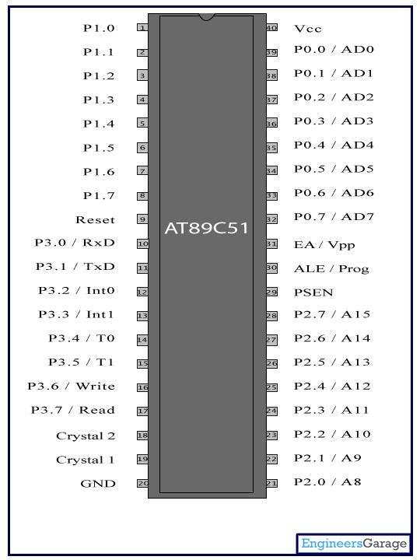

Figure 3.2.1. Pin Diagram for Microcontroller

# 3.2.1.89C51 MICRO CONTROLLER ARCHITECTURE:

The 89c51 architecture consists of these specific features:

* Eight –bit CPU with registers A (the accumulator) and B
* Sixteen-bit program counter (PC) and data pointer (DPTR)
* Eight- bit stack pointer (PSW)
* Eight-bit stack pointer (SP)
* Internal ROM or EPROM (8751) of 0(89c31) to 4K (89c51)
* Internal RAM of 128 bytes:
  1. Four register banks, each containing eight registers
  2. Sixteen bytes, which may be addressed at the bit level
  3. Eighty bytes of general- purpose data memory
* Thirty –two input/output pins arranged as four 8-bit ports : p0-p3
* Two 16-bit timer/counters: T0 and T1
* Full duplex serial data receiver/transmitter: SBUF
* Control registers: TCON, TMOD, SCON, PCON, IP, and IE
* Two external and three internal interrupts sources.

# HARDWARE DESCRIPTION:

The system consists of the following hardware components:

1. Thermistor
2. Relay
3. Power supply

## THERMISTOR:

At low temperature the thermistors have high resistance. But the resistance decreases if the thermistors warm up. At that time the current flow the them. It will take few

seconds to drop the resistance when the thermistor is warmed up. The current flows at positive 9 volts to negative 0volts. The LED will glow if the current flows into the transistor’s base.

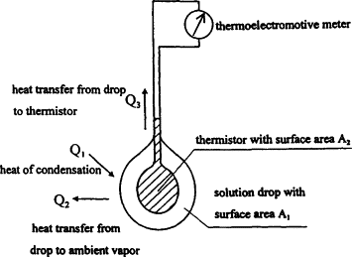

Figure 3.3.1. Thermistor

# HEAT SENSOR CIRCUIT:

When the heat level is low the resistance of the thermistor is high. This prevents current from flowing to the base of the transistors. Consequently, the LED does not light. However, when heat falls onto the thermistor its resistance falls and current flows into the base of the first transistor and then the second transistor. The LED lights. The preset resistor can be turned up or down to increase or decrease resistance, in this way it can make the circuit more or less sensitive.

# RELAY:

A relay is an electrical switch that opens and closes under the control of another electrical circuit. In the original form, the switch is operated by an electromagnet to open or close one or many sets of contacts. It was invented by Joseph Henry in 1835. Because a relay is able to control an output circuit of higher power than the input circuit, it can be considered to be, in a broad sense, a form of an electrical amplifier.

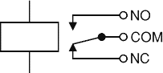

Figure 3.3.3. Relay

# POWER SUPPLY:

A variable regulated power supply, also called a variable bench power supply, is one where you can continuously adjust the output voltage to your requirements. Varying the output of the power supply is the recommended way to test a project after having double checked parts placement against circuit drawings and the parts placement guide. This type of regulation is ideal for having a simple variable bench power supply. Actually, this is quite important because one of the first projects a hobbyist should undertake is the construction of a variable regulated power supply. While a dedicated supply is quite handy e. g. 5V or 12V, it's much handier to have a variable supply on hand, especially for testing. Most digital logic circuits and processors need a 5volt power supply. To use these, parts we need to build a regulated 5volt source. Usually, you start with an unregulated power supply ranging from 9 volts to 24 volts DC.

# CHAPTER – 4 RESULT AND DISCUSSION

The significance of the project is to deliver street light to everyone with savings of energy and power. We can also reduce money cost by using thermistor and relay. The street lighting system is very easy to made. We can make it providing low cost and a few workers. Its saves a huge amount of power and energy for us. Here we are saving lot of power without any wastage, by these advanced technologies we can design many more systems which can be done by solar lights and through these solar lights we have a vast usage at the same time we can do automatic systems instead of doing it manually.

Secondly, using highly advanced IC’s and with the help of growing technology the project has been successfully implemented.

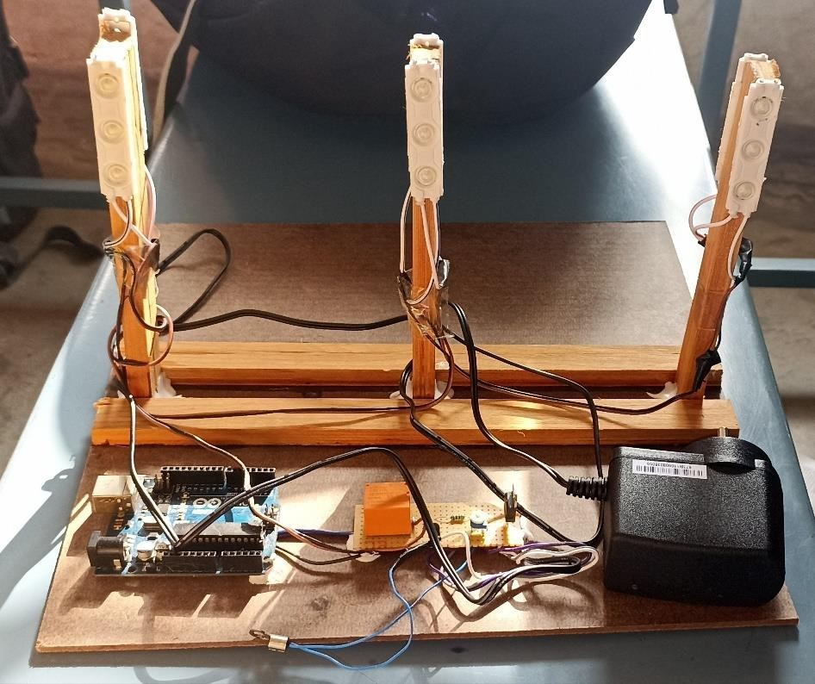

Figure 4.1. Hardware Configuration.

# CHAPTER - 5 CONCLUSION

The project “Automatic Street Light Control System with thermistor and Microcontroller” has been successfully designed and tested. Here we are saving lot of power without any wastage, by these advanced technologies we can design many more systems which can be done by solar lights and through these solar lights we have a vast usage at the same time we can do automatic systems instead of doing it manually.

Secondly, using highly advanced IC’s and with the help of growing technology the project has been successfully implemented.

# REFERENCES

[1] D. A. Devi and A. Kumar, Design and Implementation of CPLD based Solar Power Saving System for Street Lights and Automatic Traffic Controller, *International Journal of Scientific and Research Publications,* Vol. 2, Issue 11, November 2012.

[2] J. Mohelnikova, Electric Energy Savings and Light Guides, Energy& Environment, *3rd IASME/WSEAS International Conference on, Cambridge, UK,* February 2008, pp.470- 474.

[3] M. A. Wazed, N. Nafis, M. T. Islam and A. S. M. Sayem, Design and Fabrication of Automatic Street Light Control System, *Engineering e-Transaction,* Vol. 5, No. 1, June 2010, pp 27-34.

[4] R. Priyasree, R. Kauser, E. Vinitha and N. Gangatharan, Automatic Street Light Intensity Control and Road Safety Module Using Embedded System, *International Conference on Computing and Control Engineering,* April 2012.

[5] K. S. Sudhakar, A. A. Anil, K. C. Ashok and S. S. Bhaskar, Automatic Street Light Control System, *International Journal of Emerging Technology and Advanced Engineering,* Vol. 3, May 2013, PP. 188-189